**Design Report : AgriCopter Farm Monitoring Application**

**The Problem:**

One of the essential functional purposes of the AgriCopter is to ensure maximum optimization by minimum spraying of pesticides, fertilizers and other such chemicals. Currently, many farmers do not have an efficient means to keep track of the data on exactly how much of these chemicals they have sprayed throughout the farming season. They also do not have easy access to data from previous seasons, which makes it difficult for them to keep track of the improvements in optimization over the years.

**The Solution:**

The AgriCopter FMA is a software application that accompanies the AgriCopter in its aim to optimize pesticide spraying. The application keeps track of every activity performed by the drone. Every time the drone sprays some chemicals over the field, the application will create a record of exactly how much chemical was sprayed over what area of the field. This data will be stored in a database and can be easily accessed by the farmer or data analyst for further use.

**Current Version and Future Implementations:**

The current version of the application will keep track of all spraying activities of the drone. Surveying analysis and live drone tracking is done from Pix4D, which is commercial software. Future implementations will aim to bring all these activities under the single purview of our own in-house application, the AgriCopter FMA.

Furthermore, the current version requires user input for date of spraying, land area sprayed, and spray density. After the construction of the final drone, these values will be provided as automated input by the flight control unit.

**Front-End User Interface:**

The initial Main Screen will give the user three options from a menu: (i) chemical spray analysis (ii) survey analysis (iii) drone statistics.

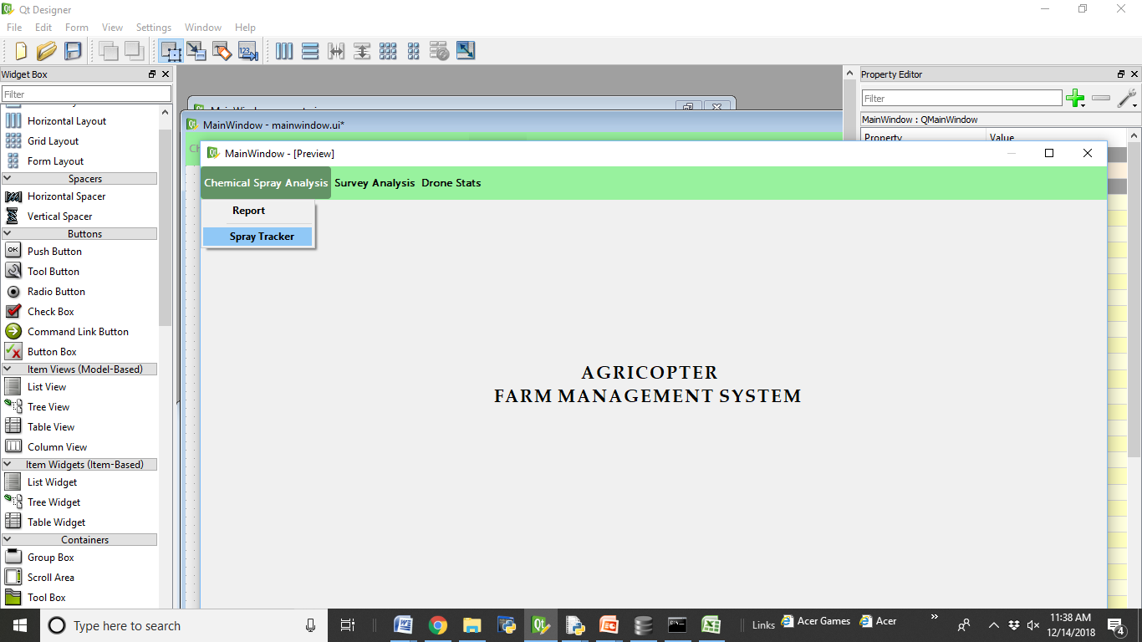

(i) Chemical Spray Analysis: This mode has two more internal modes: Spray Tracking and Report Display

(ii) Survey Analysis: (In a future version) This mode will allow the user to look at the images from the multispectral sensors and the spraying prescriptions based on the identified stressed regions.

Main Menu

(iii) Drone Stats (In a future version) This mode will allow the user to monitor the drone statistics post flight on a weekly or monthly basis. Drone statistics are currently being tracked live on drone-tracking software. Certain customizable reports will be provided in our system to analyze drone flight statistics, which will be useful to the user.

Let us now look into the Chemical Spray Analysis mode (Mode 1) in more detail. There are two features within this mode: spray tracking and report.

**1. Spray Tracking:**

At any time, the user can view the data existing in the database using the spray tracking feature. He will be allowed to view data for either the entire season, or for a particular week

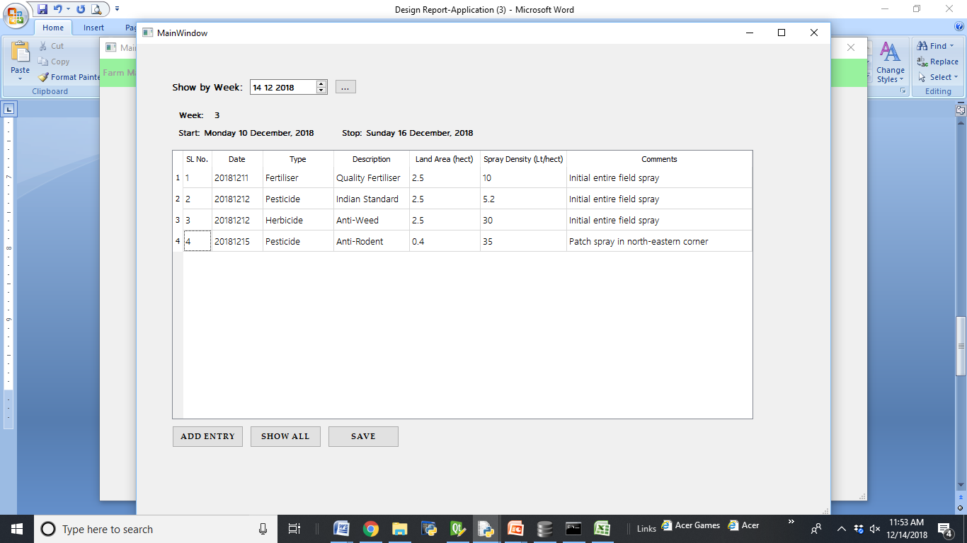

Table depicting the sprays in a particular week

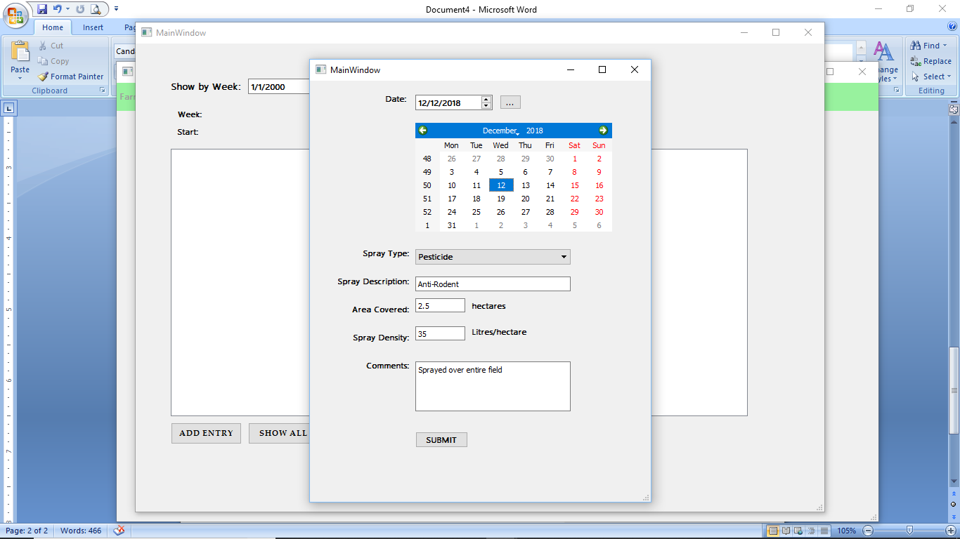The table above depicts the values stored in the database.

Upon hitting the Add Entry button, Spray Tracking will allow the user to enter data for a new spray in a form as shown in the screenshot.

Show All will display the data for an entire season. This window also allows you to modify the values stored in the table, the Save button will save any changes the user makes to the table.

**2. Report:**

On selecting the Report option from the Main Menu, the system will provide a more relevant and user-friendly report for the farmer, to enable him/her to monitor the pesticide spraying activities of the AgriCopter. The Report Mode will publish two kinds of reports. One report for the entire season, and one report for a particular week.

The add entry form that will allow the user to input data for a new spray

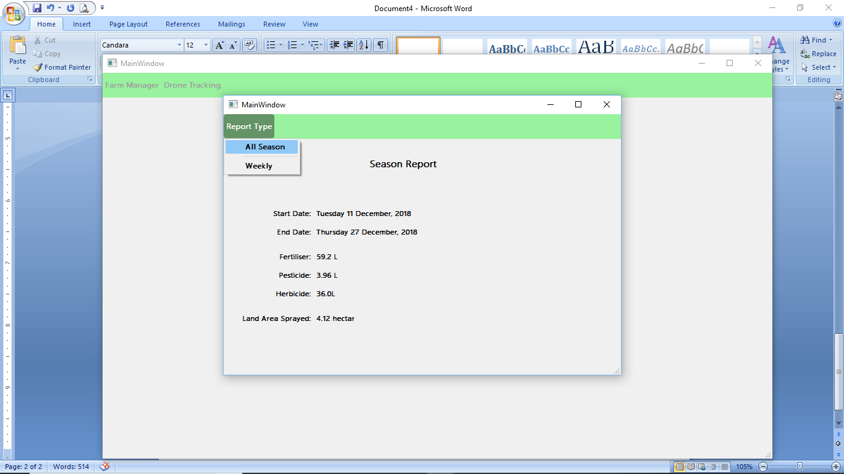

In order to view a weekly report, the user will first have to select a date from the calendar widget. After selecting a date, he/she will be able to view the report for the week.

A sample of an entire season report

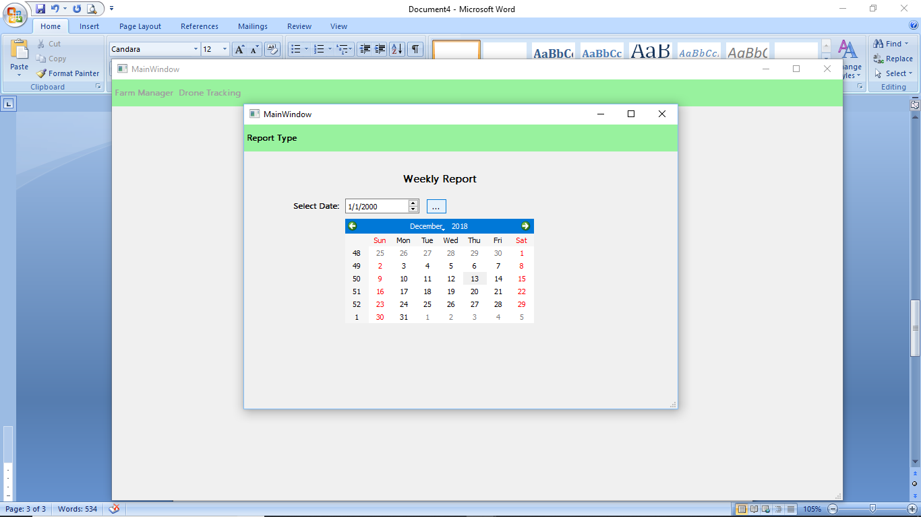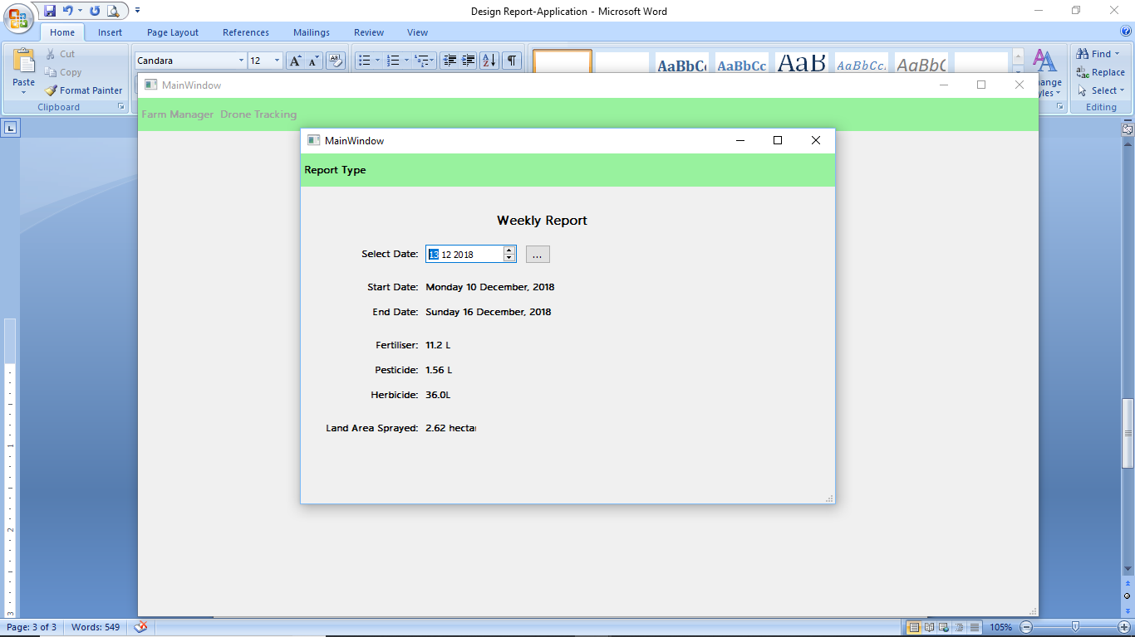

Then view the report for the week containing that date

First enter a date

**Summary:**

The AgriCopter pesticide tracking application provides an excellent platformfor a farmer to track his/her pesticide spraying tendencies.